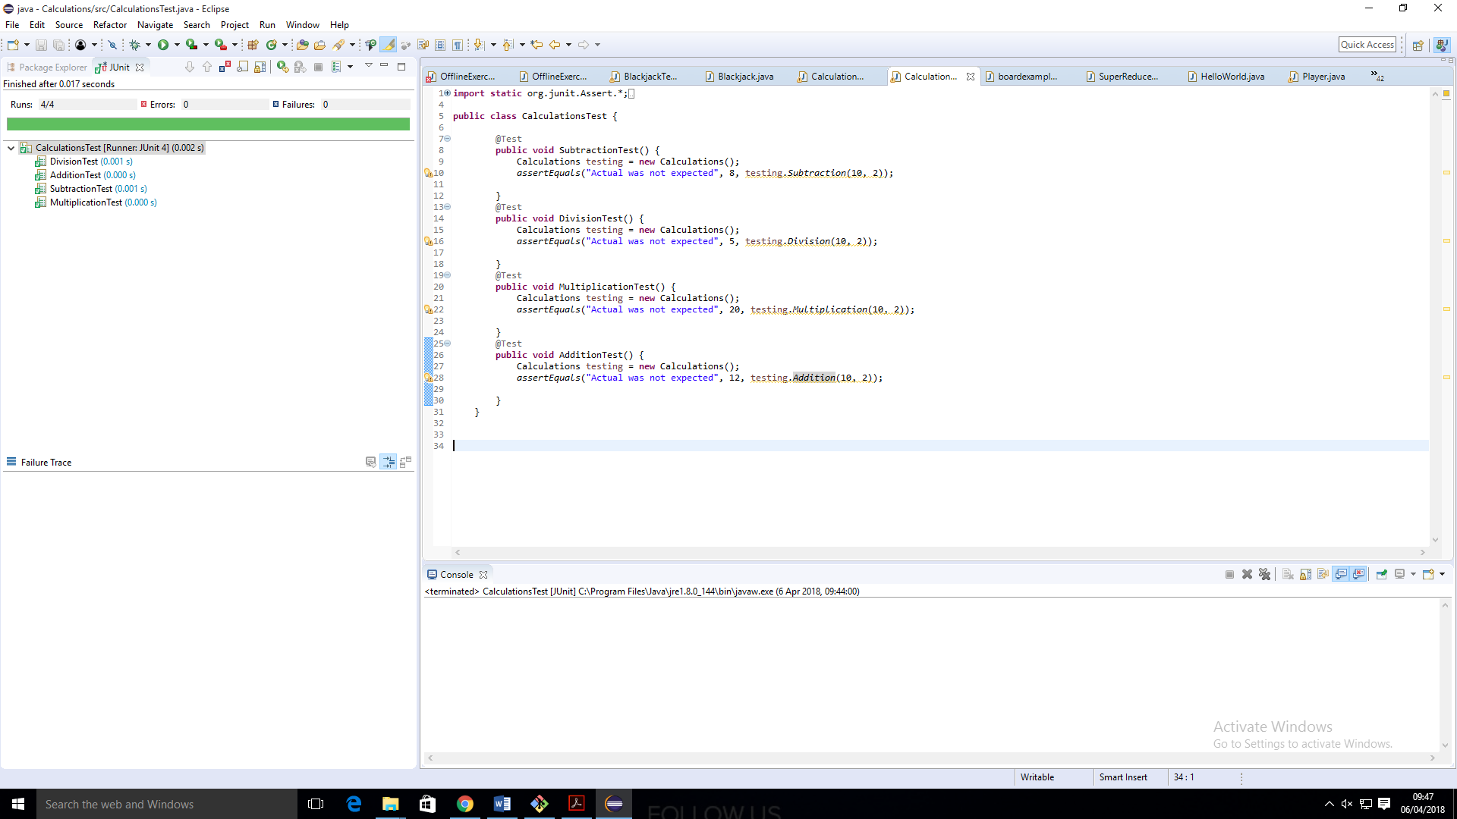 **DevOps Assessment Project** 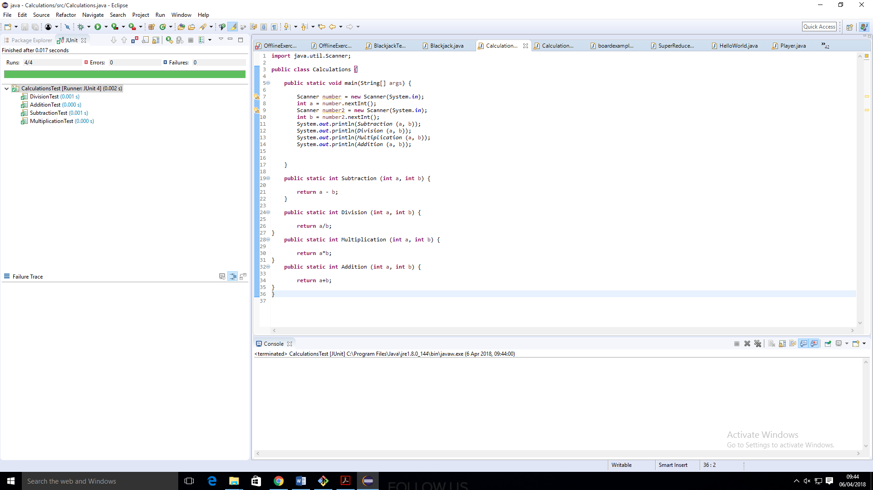

1.

I created a simple application that subtracts, divides, multiplies and adds the same two numbers inputted by the user. I then used Junit to test each of these calculation methods.